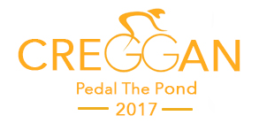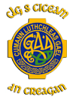
Dear Sir/Madam
The committee of Kickhams GAC Creggan are organising one major fundraiser in 2017 – a cycling event called ‘Pedal the Pond’. This event will help the club grow and develop and will also act as major charity fundraiser.
On 6th August 2017 it is our intention to have upwards of 200 cyclists completing either a minor route of 50 miles or an advanced route of 90 miles. This challenging and inclusive one day cycle event will leave Kickhams GAC, Creggan on Sunday 6th August travelling around Lough Neagh using various cycle routes and returning to Creggan for a celebration Barbeque and dance in Creggan Sports Centre.
As part of ‘Pedal the Pond’ we are designing and producing a one-off commemorative cycling jersey for all participants. We would like to invite you to support the event by adding your name or company logo to the jersey as one of our sponsors. Attached is a copy of the Sponsorship options which we hope that you will be able to support.
One of the major goals of the cycle is to raise funds for 5 charities that have been chosen by our local community. These charities are:
- Northern Ireland Cancer Fund for Children
- Chest Heart and Stroke
- Trocaire - helping fight hunger and poverty across the world
- Aware NI – a charity that helps people deal with mental health issues such as depression
- MacMillan Cancer
We would be delighted if you too could help us build our future and help us support these very worthwhile charities. All sponsors will be automatically included in the event chequer-board which will be used at all PR opportunities leading up to the event and then erected after the event in the Kickhams GAC Sports Centre. We will also be promoting all of our sponsors on the Clubs social media channels
In anticipation of your valued support, we look forward to promoting your business and enjoying our ‘Pedal the Pond’ cycle. All cheques should be made payable to “Kickhams GAC” and addressed to Terry Robb, Kickhams GAC, 3 Randal Close, Ahoghill Road, Randalstown, Co Antrim, BT41 3DF
If you have further queries please contact me on terryrobb0710@icloud.com or on 07766 071082
Regards

Terry Robb
Cycling Club Chair

